**PyCharm install guide**

We are installing PyCharm version **2022.2.3**, so ignore the following steps if that isn’t the current version. Go to **Follow from here after .exe download** once downloaded needed version

Go to <https://www.jetbrains.com/pycharm/download/?section=windows>

**Scroll down**

Ensure you are under “community edition,” and type is “.exe”

Click download

Wait for the .exe to finish downloading

**Follow from here after .exe download**

Double click the .exe to open.

Click next

“C:\Program Files\JetBrains\PyCharm Community Edition 2023.1.3”

This is the path (no quotations) that should show up in the next screen. If not, change it.

**Continue Next Page**

**Change the options** to those shown below.

Create Desktop Shortcut

Add “bin” folder to the PATH

Create Associations:

“.py”

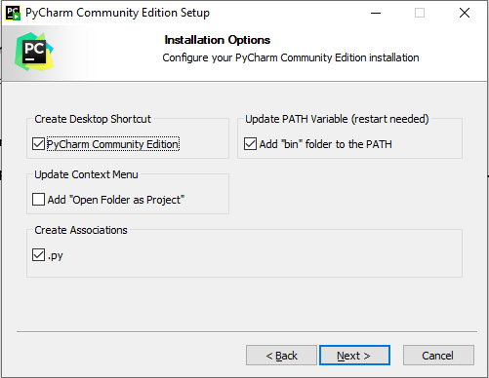

**Accept** default location folder as “jetbrains”

**Click** install

**Choose** to reboot now or later. Note that you must restart to continue installation.

**After Reboot**

Select accept terms and conditions,

**Deny** data sharing

PyCharm should boot up. From here you can open or create projects. See other documents for details.

**Optional but recommend QOL upgrades**

**Add** a note todo markup in settings

File, Settings, Search “todo,” under “patterns” click “+,” type “\bnote\b.*” and change colors to be whatever you would like. I chose a bright blue. Now, any tutorials I have added notes to will show up nicely for you.